**Heroes Of Pymoli Data Analysis**

* **OBSERVED TREND 1**

*From “Gender Demographics” report, it is very obvious, there are more males participated in the game than female and others category. This is true in genera. most of the games, where in males are more interest in games than females.*

* **OBSERVED TREND 2**

*From “Purchasing Analysis (Gender) report, it shows the average price paid by “Other/Non-disclosed” category is the highest among all others.(Male and Female). Because the count is purchase count is low.*

* **OBSERVED TREND 3**

*From “Purchasing Analysis (Age) report, it tells us there are more attendees within age group 40+ . Also higher the price Item , lower the purchase count.*

**Player Count**

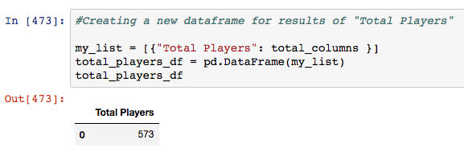

**Purchasing Analysis (Total)**

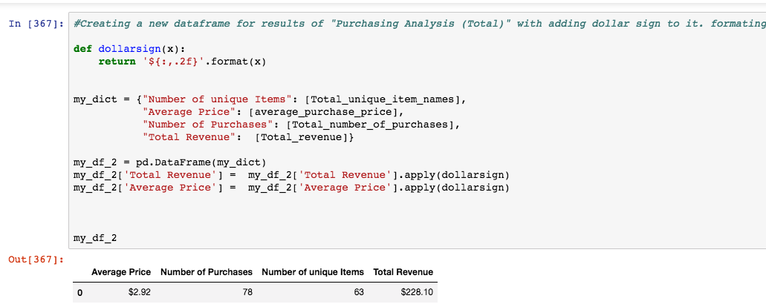

**Gender Demographics**

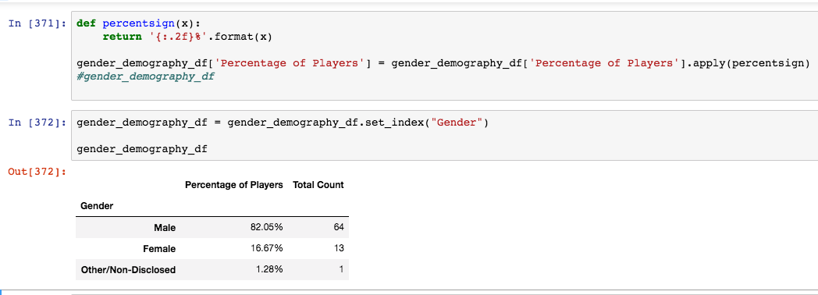

**Purchasing Analysis (Gender)**

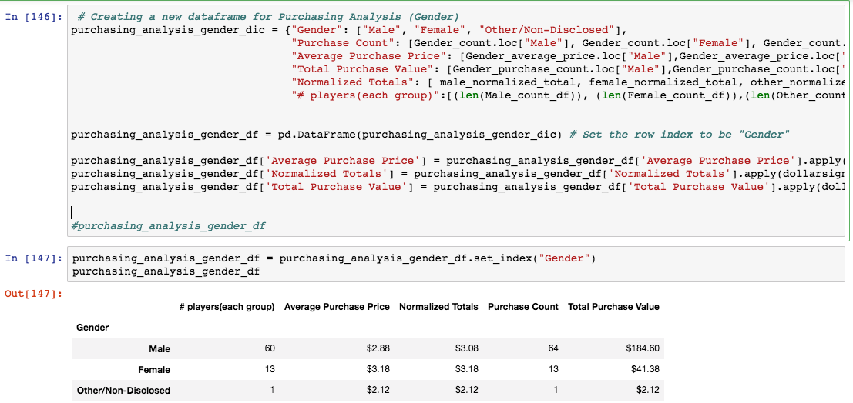

**Purchasing Analysis (Age)**

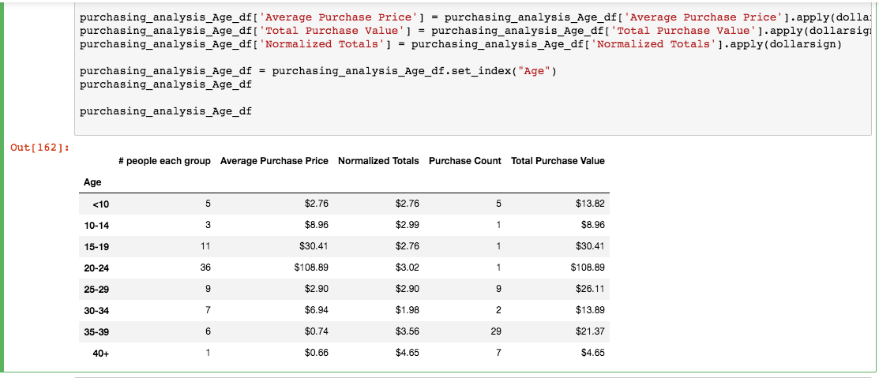

**Top Spenders**

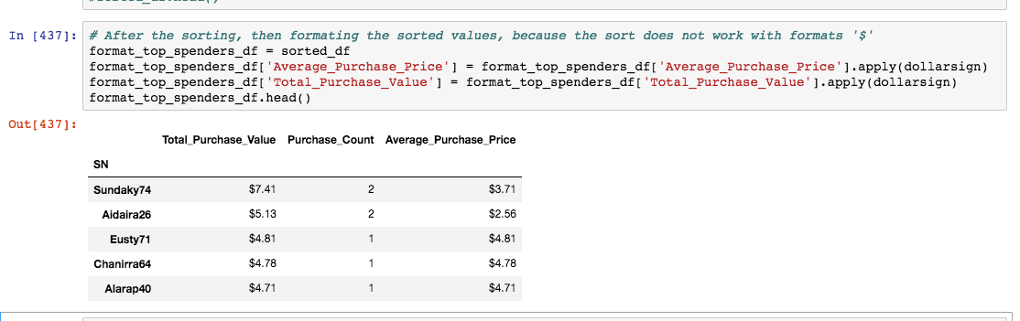

**Most Popular (Purchase Count)**

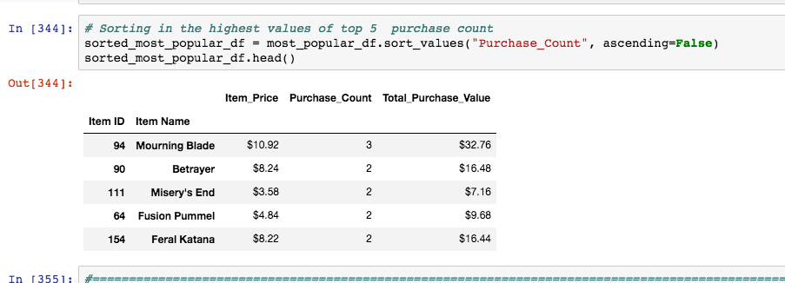

**Most Profitable (Purchase Value) Items**

